

**Power BI Report Presentation**

**at**

**Date: 01/01/2026**

By

**Apurva Singh Chauhan (20251007)**

**Astha Singh (20251009)**

**Swasti Agrawal (20251052)**

**Chirag Ubhadiya (20251014)**

**Ruchit Vaghasiya (20251045)**

**PGDM 2025-27**

In Partial Fulfillment of the Requirements for the

Post Graduate Diploma in Management (BDA)

At

**Adani Institute of Digital Technology Management**

(AICTE Approved Two-Year Full-Time Programme)

Plot No. 225, Opp. Maharaj Hotel Lane, Jamiyatpura Road,

S G Highway, PO: Jamiyatpura Gandhinagar - 382423, Gujarat.

**TABLE OF CONTENTS**

|  |  |  |
| --- | --- | --- |
| **Sr No.** | **Title** | **Page No.** |
| 1 | Introduction of Dataset | 1-2 |
| 2 | Overview of Power BI Report | 2-3 |
| 3 | Group-Specific Analysis | 3-5 |
| 4 | Key Features of the Power BI Report | 4-5 |
| 5 | Key Takeaways | 5-8 |
| 6 | Additional Insights | 8 |
| 7 | Power BI Dashboard Screenshots and Visual Evidence | 8-12 |
| 8 | Any Other References | 13 |

# Impact of Artificial Intelligence on Jobs, Skills, and Career Strategy (2030)

This report presents an in-depth analytical study of how Artificial Intelligence (AI) and automation are expected to transform jobs, skills, and career strategies by the year 2030 using Power BI as a Business Intelligence tool.

# 1. Introduction to the Dataset

The AI_Impact_on_Jobs_2030dataset is a structured and future-oriented dataset designed to analyze the long-term impact of **Artificial Intelligence (AI), automation, and advanced digital technologies** on employment patterns by the year 2030. The dataset has been curated to represent how technological advancement is reshaping job roles, required skills, salary structures, and career sustainability across industries.

Unlike traditional job market datasets that primarily focus on salary or job titles, this dataset captures a **multi-dimensional view of the workforce**. It integrates economic indicators, educational background, years of experience, skill composition, automation probability, AI exposure, and growth factors. This integrated design allows for a deeper understanding of workforce transformation rather than isolated trend analysis.

The dataset supports:

* **Descriptive analysis** by summarizing existing patterns in salary, skills, and risk
* **Diagnostic analysis** by explaining why certain roles are more vulnerable to automation
* **Strategic analysis** by identifying future-ready career paths and skills

This makes the dataset highly suitable for Business Intelligence applications using tools such as Power BI.

The dataset includes the following key variables:

* Job titles across multiple sectors and functional domains
* Salary indicators including minimum, maximum and average salary
* Education levels and years of professional experience
* Skill composition represented through multiple skill dimensions
* Automation probability indicating susceptibility to automation
* AI exposure index representing the degree of AI interaction in roles
* Career growth and technology adoption indicators

Together, these variables enable an in-depth analysis of how **skills, education, experience, and technology interact to influence career outcomes.**

## 1.1 Importance of the Dataset

The importance of the AI_Impact_on_Jobs_2030 dataset lies in the increasing global concern regarding **job displacement, skill obsolescence, and workforce restructuring** caused by rapid AI adoption. As organizations increasingly automate repetitive and rule-based tasks, many traditional job roles are being redesigned, while demand for analytical, technical, and human-centric roles is increasing.

This dataset provides **data-backed insights** that help different stakeholders make informed decisions:

* **Students and professionals** can identify future-proof careers and skill requirements
* **Organizations** can plan reskilling and workforce transformation strategies
* **Educators** can align academic curricula with industry needs
* **Policymakers** can anticipate long-term employment trends

By bridging the gap between **technological trends and labor market planning,** the dataset plays a crucial role in strategic workforce analysis and career planning.

## 1.2 Objectives of the Dataset

The dataset was analyzed with the following objectives:

1. To analyze salary trends across job roles, education levels, and experience bands
2. To identify and interpret critical skills required for long-term job sustainability
3. To assess automation probability and AI exposure risks across professions
4. To support strategic, data-driven career planning using interactive visualization and analytics

# 2. Overview of the Power BI Report

The primary objective of this Power BI report is to **convert raw employment and skill-related data into interactive and meaningful visual insights** that support informed and data-driven decision-making. The report focuses on understanding how AI influences job market behavior, salary distribution, skill demand, automation risk, and long-term career resilience.

Power BI was selected as the analytical platform due to its strong **data modeling capabilities, DAX (Data Analysis Expressions) support, interactive slicers, and drill-down features.** These capabilities enable complex datasets to be presented in a visually intuitive and decision-oriented manner.

## 2.1 Key Metrics Covered

The report includes the following **Key Performance Indicators (KPIs):**

* Average Salary to represent overall market benchmarks
* Minimum and Maximum Salary to analyze salary dispersion
* Average Automation Probability (2030)
* AI Exposure Index to measure AI interaction in job roles
* Skill Count and Skill Strength indicators
* Tech Growth Factor
* Experience versus Salary progression

Together, these KPIs provide a **balanced evaluation of financial reward, job stability, and future growth potential.**

# 3. Group-Specific Analysis

**3.1 Group Focus and Analytical Scope**

Our Group primarily focused on analysing career sustainability, skill relevance, and automation risk mitigation in the context of an AI-driven job market. The core objective of this group was to understand how different professions are likely to evolve by 2030 and to identify the key factors that determine whether a job role remains resilient or becomes vulnerable to automation.

Rather than analysing salary trends in isolation, the group adopted a skill-centric and risk-aware analytical approach, which aligns with modern workforce planning and human capital management practices. The analysis emphasized the interaction between skills, AI exposure, automation probability, experience level, and salary growth, providing a balanced evaluation of both economic and career stability factors.

This approach ensures that the findings are not only descriptive but also strategic and actionable, helping individuals and organizations make informed career and workforce decisions.

**3.1 Visualizations Used and Their Purpose**

To support the group’s analytical objectives, multiple Power BI visualizations were designed and analysed. Each visualization serves a specific analytical purpose and contributes to a comprehensive understanding of career dynamics under AI influence.

**3.2.1 Salary Distribution by Job Role**

This visualization compares average salary levels across different professions to identify income variation and compensation trends. It helps assess whether high-paying roles also offer long-term sustainability.

**3.2.2 Salary by Education Level**

## This visual examines how different education levels impact salary outcomes. It highlights whether higher education consistently leads to better compensation or if skill relevance plays a stronger role.

## 3.2.3 Skill Demand and Skill Mapping (Scatter )

## This visualization represents the intensity and distribution of key skills across job roles. It helps identify which skills are most critical for future job sustainability and which roles demand a higher combination of transferable skills.

## 3.2.4 Automation Risk and AI Exposure Analysis

## This chart evaluates the relationship between automation probability and AI exposure index across professions. It clearly distinguishes between high-risk, medium-risk, and low-risk roles in an AI-enabled economy.

## 3.2.5 Career Strategy Table

## The career strategy table integrates multiple indicators such as salary level, automation risk, AI exposure, and growth potential. This visualization supports comparative analysis and strategic career decision-making.

## 3.2.6 Experience vs Career Growth Visualization

## This visual analyses how experience influences career growth and salary progression over time. It helps identify stages where growth plateaus and highlights the importance of skill enhancement beyond experience alone.

## 3.3 Interpretation of Findings

## The group-specific analysis revealed several important insights regarding the future of work under AI influence:

## Knowledge-intensive and skill-driven roles consistently exhibit lower automation probability compared to routine and repetitive roles.

## High salary does not necessarily guarantee job security, as some well-paid roles still show moderate to high automation risk.

## Roles requiring analytical thinking, technical specialization, data literacy, and strategic planning demonstrate greater resilience to AI disruption.

## Career growth tends to stabilize after mid-level experience, indicating that skill upgradation is more critical than tenure alone.

## Job roles with diverse and transferable skill sets are better positioned to adapt to technological change.

## These findings reinforce the idea that career sustainability in the AI era depends more on skills and adaptability than on traditional factors such as job title or salary alone.

## 3.4 Strategic Implications of Group 4 Analysis

## Based on the insights derived from the visualizations, Group 4 emphasizes the following strategic implications:

## Individuals must adopt a continuous learning mindset to remain competitive in the evolving job market.

## Career planning should incorporate automation risk and AI exposure, not just salary growth.

## Organizations should proactively identify roles at risk and implement reskilling and internal mobility programs.

## Educational institutions should align curricula with future-ready skills highlighted in the analysis.

## 3.2 Interpretation of Findings

The analysis indicates that **knowledge-intensive and skill-driven roles** tend to have lower automation probability, whereas routine and repetitive roles face significantly higher automation risk. It was also observed that **salary alone is not a reliable indicator of job security**, as some high-paying roles still exhibit moderate exposure to automation.

Roles requiring **diverse and transferable skills** demonstrate greater adaptability and long-term resilience, reinforcing the importance of continuous learning and skill diversification.

# 4. Key Features of the Power BI Report

The Power BI report incorporates multiple advanced features to enhance analytical depth, usability, and interpretability.

**4.1 Interactive Filters and Slicers**

Interactive slicers for Job Title, Education Level, and Risk Category allow users to dynamically customize their analysis. This supports **scenario-based exploration**, improves usability, and enhances analytical flexibility.

## 4.2 Advanced and Dynamic Visualizations

## The report uses bar charts, scatter plots, line charts, and heatmaps to represent multiple analytical dimensions. These visuals support **pattern recognition, trend identification, and comparative analysis**, making complex relationships easier to interpret.

## 4.3 Custom Measures Using DAX

## Custom DAX measures were developed to calculate Average Salary, Automation Probability (2030), AI Exposure Index, Tech Growth Factor, and Risk Categorization (Low, Medium, High). These measures improve **accuracy, consistency, and analytical reliability** across visuals.

**Skill Count** = (INT('AI_Impact_on_Jobs_2030'[Operational_Execution] > 0.5) + INT('AI_Impact_on_Jobs_2030'[Interpersonal_Communication] > 0.5) + INT('AI_Impact_on_Jobs_2030'[Technical_Specialization] > 0.5) + INT('AI_Impact_on_Jobs_2030'[Analytical_Thinking] > 0.5) + INT('AI_Impact_on_Jobs_2030'[Research_Methodology] > 0.5) +INT('AI_Impact_on_Jobs_2030'[Strategic_Planning] > 0.5) +INT('AI_Impact_on_Jobs_2030'[Customer_Service_Aptitude] > 0.5) +INT('AI_Impact_on_Jobs_2030'[Professional_Judgment] > 0.5) +INT(AI_Impact_on_Jobs_2030[Emotional_Intelligence] > 0.5) +INT(AI_Impact_on_Jobs_2030[Data_Literacy] > 0.5))

**Final Risk Category** = MAX('AI_Impact_on_Jobs_2030'[Risk_Category])

**Salary Band** = IF( 'AI_Impact_on_Jobs_2030'[Average_Salary] >= 80000, "High Salary", "Low / Medium Salary")

**Min Salary** = MIN('AI_Impact_on_Jobs_2030'[Average_Salary])

## 4.4 Skill Column Renaming and Feature Engineering

Initially, the dataset contained generic skill columns labeled Skill_1 to Skill_10, which limited interpretability. Domain-driven feature engineering was applied by renaming these columns into meaningful real-world competencies such as Analytical Thinking, Data Literacy, Technical Specialization, and Emotional Intelligence.

This transformation improved clarity of visuals, enhanced realism of insights, and strengthened skill-based recommendations.

## Hierarchies and Drill-Down Analysis

## Hierarchies were created for Education Level, Experience Level, and Job Role classification to enable **multi-level data exploration**. Users can move from high-level summaries to detailed insights, improving analytical depth and user experience.

## 4.6 Skill Column Renaming and Feature Engineering

Initially, the dataset contained generic skill columns labeled **Skill_1 to Skill_10**, which limited interpretability. To address this limitation, **domain-driven feature engineering** was applied by renaming these columns into meaningful real-world competencies. The renaming process ensured that each skill column accurately reflected the underlying capability it represents, thereby improving visualization interpretability and strengthening skill-based insights and recommendations.

|  |  |
| --- | --- |
| **Original Column Name** | **Updated Skill Name** |
| Skill_1 | Operational_Execution |
| Skill_2 | Interpersonal_Communication |
| Skill_3 | Technical_Specialization |
| Skill_4 | Analytical_Thinking |
| Skill_5 | Research_Methodology |
| Skill_6 | Strategic_Planning |
| Skill_7 | Customer_Service_Aptitude |
| Skill_8 | Professional_Judgment |
| Skill_9 | Emotional_Intelligence |
| Skill_10 | Data_Literacy |

Table 4.2: Skill Column Name Change Mapping

This transformation improved **visual clarity, interpretability, and relevance of insights**, demonstrating effective application of domain knowledge in data analytics.

# 5. Key Takeaways

* Analytical and data-centric skills significantly reduce automation exposure
* Salary growth stabilizes after mid-level experience
* Routine and repetitive roles face the highest automation risk
* Skill diversity enhances long-term career resilience
* Skills often outweigh formal education in determining job sustainability

## 5.1 Strategic Recommendations

* Individuals should prioritize continuous upskilling in analytical and digital skills
* Career planning should integrate salary, growth potential, and automation risk
* Organizations should adopt AI-resilient workforce strategies through reskilling initiatives

# 6. Additional Insights

### ****6.1 Challenges and Limitations****

* Predictive nature of the dataset
* Absence of real-time labor market data
* Aggregated skill metrics

### ****6.2 Future Enhancements****

* Integration of real-world employment datasets
* Industry-specific and geographic segmentation
* Longitudinal trend forecasting
* Inclusion of diversity and inclusion metrics

**7. Power BI Dashboard Screenshots and Visual Evidence**

**7.1 Purpose of Including Dashboard Screenshots**

This section presents visual evidence of the Power BI dashboards developed as part of the analysis. The screenshots are included to demonstrate the practical implementation of data modeling, visualization techniques, and analytical insights discussed in earlier sections of the report.

The dashboards visually represent key findings related to salary trends, skill demand, automation risk, AI exposure, and career sustainability. Including these screenshots enhances the credibility of the analysis and allows evaluators to directly observe how insights were derived from the data.

**7.2 Dashboard Overview**

The Power BI dashboard is structured across multiple pages, each designed to address a specific analytical objective. The dashboard combines interactive visuals, slicers, KPIs, and comparative charts to provide a comprehensive and user-friendly analytical experience.

Each dashboard page supports interactive exploration, allowing users to filter results by job role, education level, experience, and risk category.

**7.3 Dashboard Pages and Visual Descriptions**

**7.3.1 Salary and Career Overview Dashboard**

This dashboard provides a high-level overview of salary distribution across different job roles and education levels. It helps identify income variation and understand how education and experience influence compensation patterns.

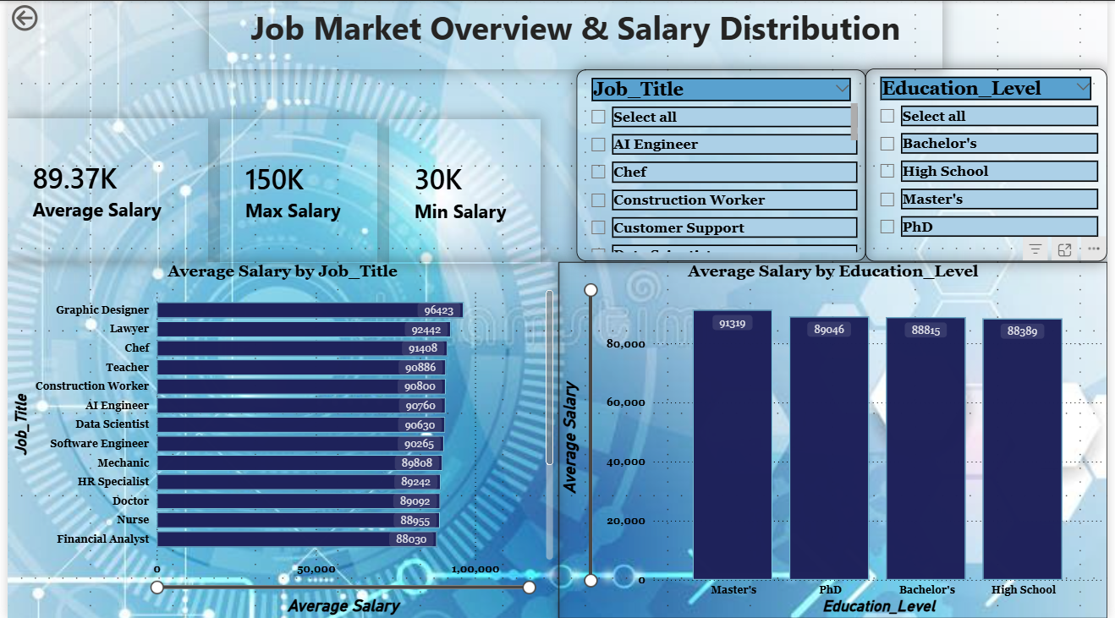

**7.3.2 Skill Demand and Skill Mapping Dashboard**

This dashboard visualizes the distribution and intensity of key skills across job roles. It highlights which skills are most critical for future job sustainability and how skill requirements vary across professions.

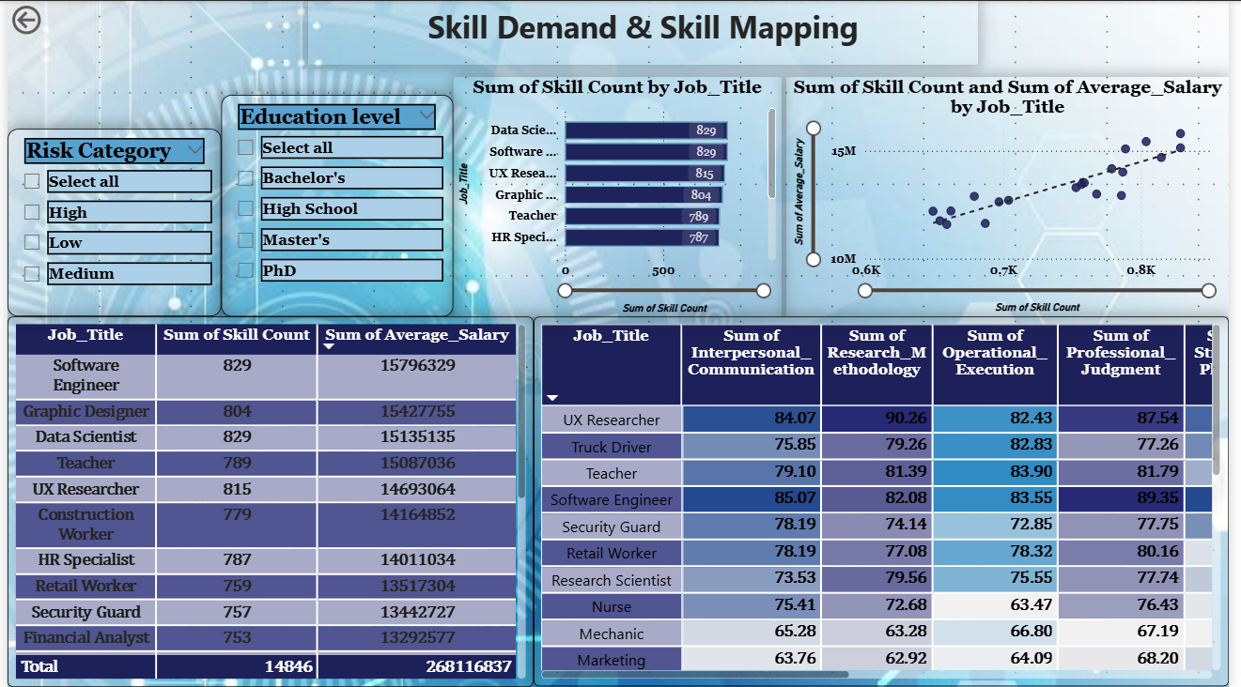

**7.3.3 Automation Risk and AI Exposure Dashboard**

This dashboard focuses on automation probability and AI exposure index to classify job roles into low, medium, and high-risk categories. It supports risk-aware career and workforce planning.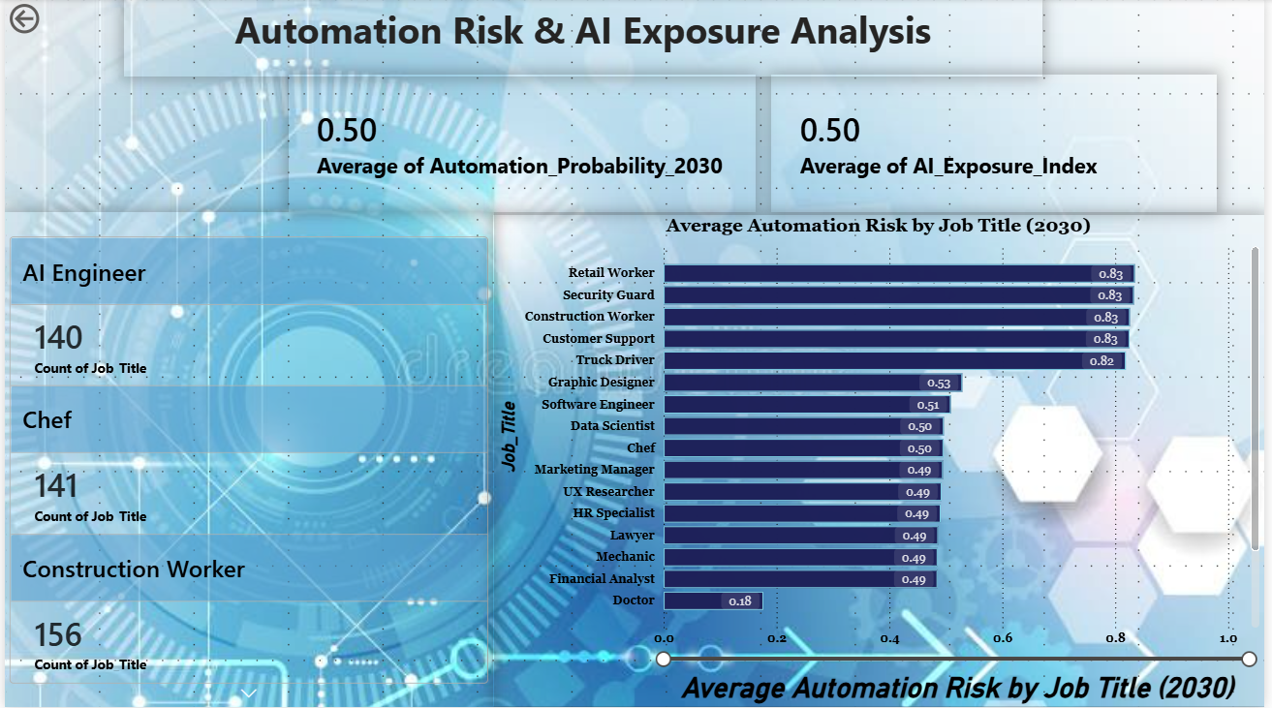

**7.3.4 Career Strategy and Growth Dashboard**

This dashboard integrates salary, growth potential, automation risk, and experience to support strategic career decision-making. It helps users evaluate trade-offs between income, stability, and long-term growth.

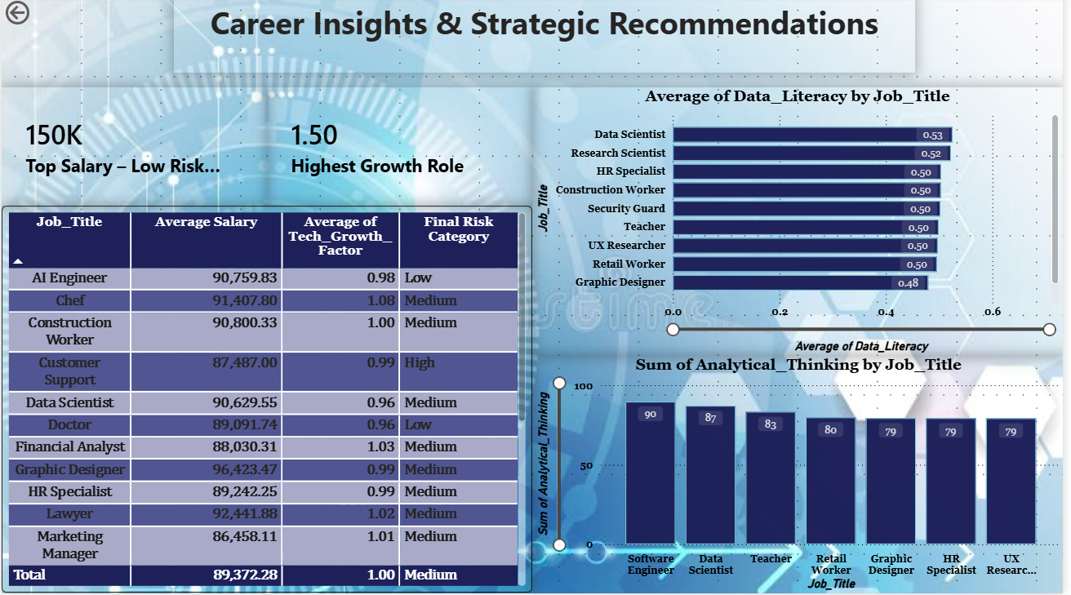

**7.3.5 Experience vs Growth Analysis Dashboard**

This dashboard analyzes how career growth and salary progression change with experience levels. It highlights stages where growth plateaus and emphasizes the importance of skill enhancement.

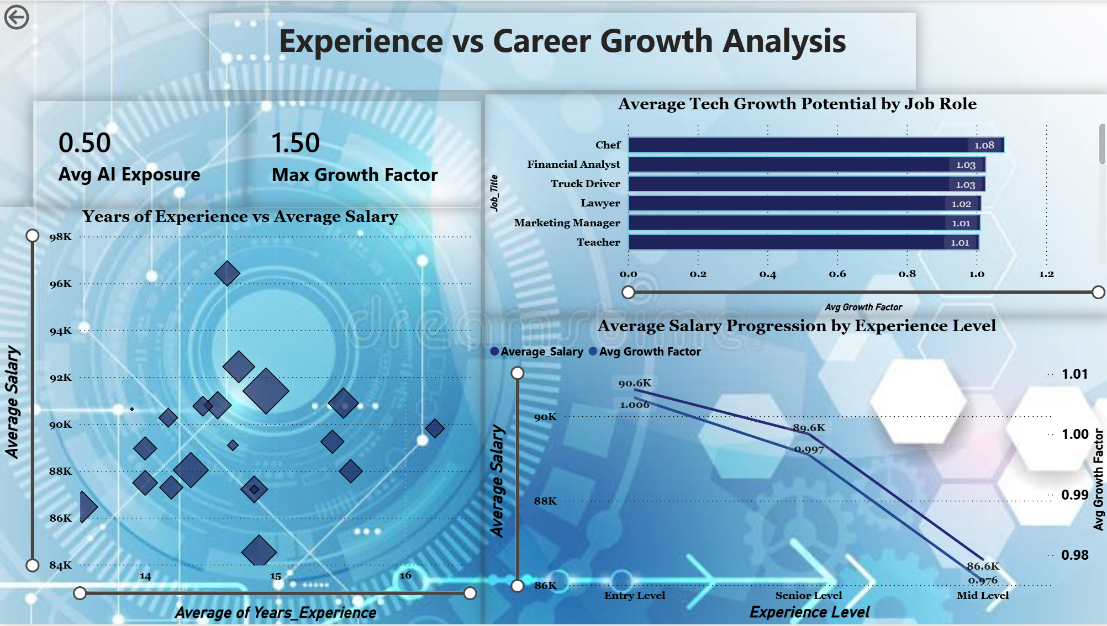

**7.4 How Dashboard Screenshots Support the Analysis**

The dashboard screenshots serve as a **visual validation** of the analytical findings discussed in earlier sections. They demonstrate:

* Effective use of Power BI visualizations and layout design
* Application of interactive slicers and filters
* Logical mapping between data, visuals, and insights
* Practical implementation of Business Intelligence concepts

By connecting visual evidence with analytical interpretation, this section strengthens the overall quality and reliability of the report.

**7.5 Summary of Dashboard Contribution**

The Power BI dashboards play a crucial role in translating complex datasets into **actionable insights**. Through interactive and well-structured visuals, the dashboards enable users to explore patterns, assess risks, and make informed career and workforce decisions.

This section confirms that the insights presented in the report are **data-driven, visually supported, and analytically sound**.

# 8. References

* AI Impact on Jobs 2030 Dataset
* Microsoft Power BI Official Documentation

# High-Scoring Final Conclusion

This report demonstrates the effective application of **Business Intelligence, data modeling, and visualization techniques** to analyze the future impact of Artificial Intelligence on jobs, skills, and career strategies. By integrating skill mapping, automation risk assessment, hierarchical analysis, and interactive Power BI dashboards, the study provides **actionable, data-driven, and future-oriented insights** that support informed career planning and strategic workforce development.